Summer language center “SMILES”
Летняя Языковая площадка
«Смайлики»
ЖАЗҒЫ ТІЛДІК МЕКТЕП АЛАҢЫ

Mentors :
Gulkevich O. N.
Kabdulina Zh. S.
Day 1 (05.06)
Theme: Hello,summer! Сәлем, жаз!
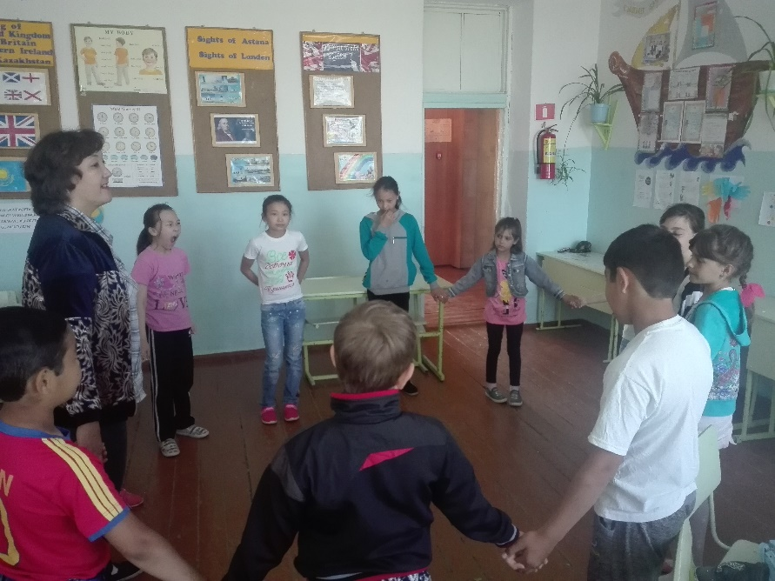
We do “Circle of joy” Every morning

Viewing English cartoon
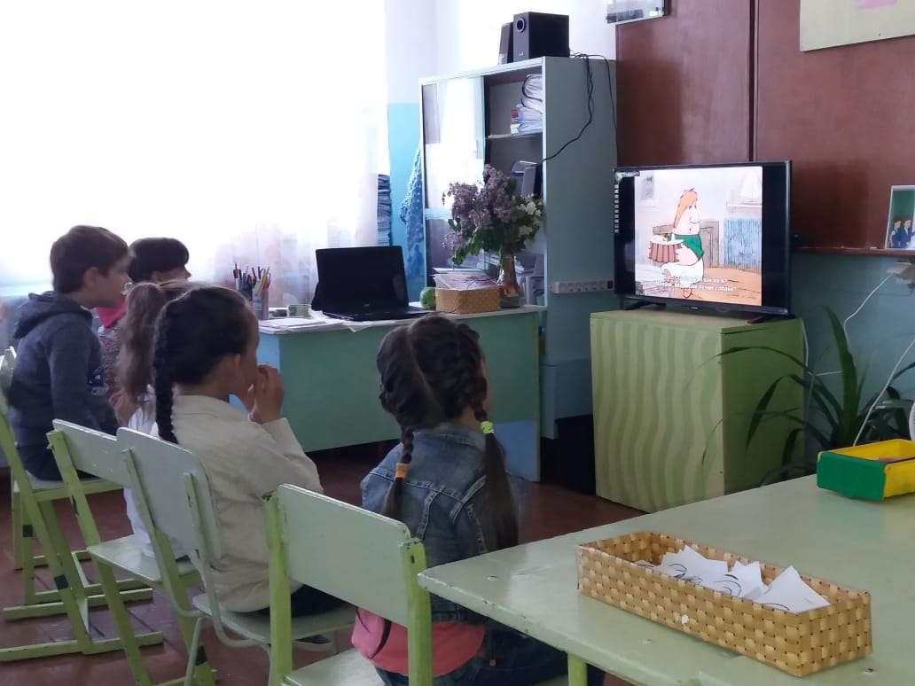

“My Portfolio"
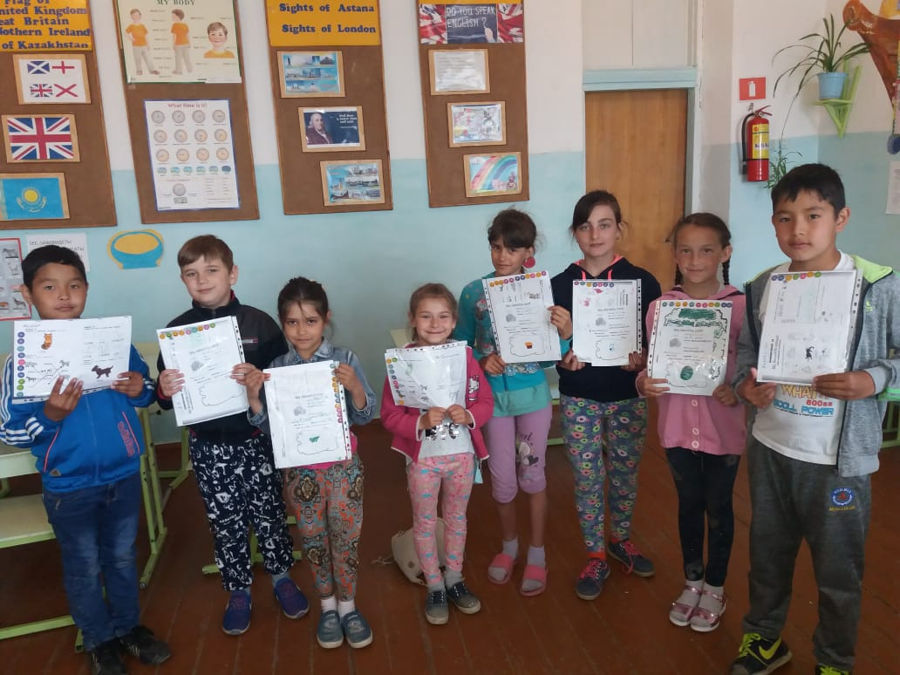

Make up “ Screen of my Success”
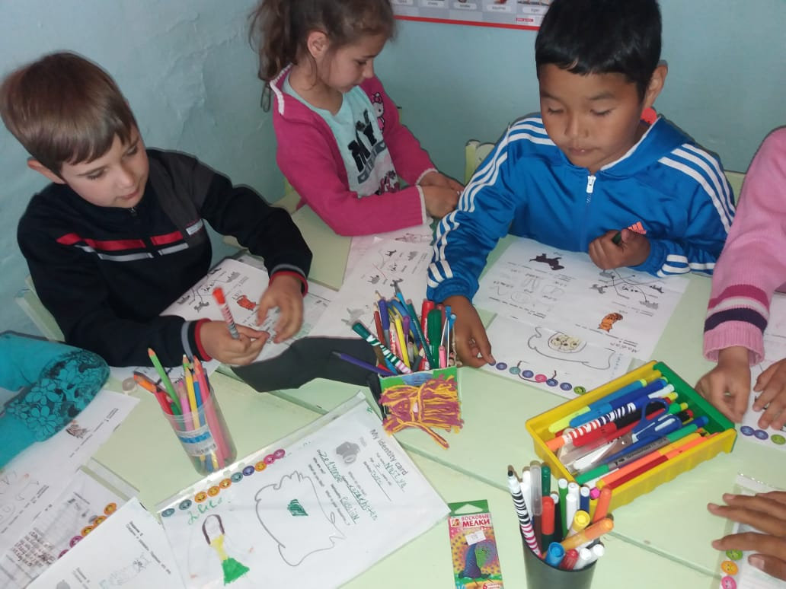

Day 2 (06.06)
Theme : Advertisement of language centre. Мектеп тілдік алаңның жарнамасы.
- Poster of the day “Smiles”
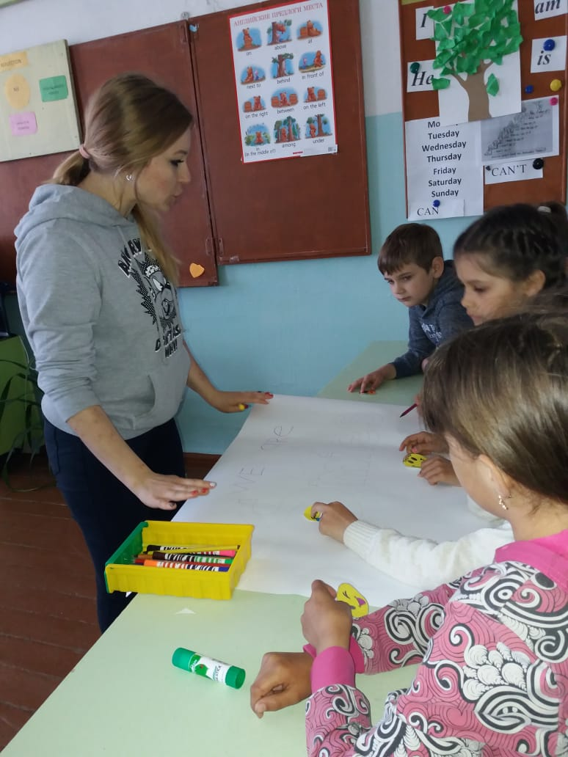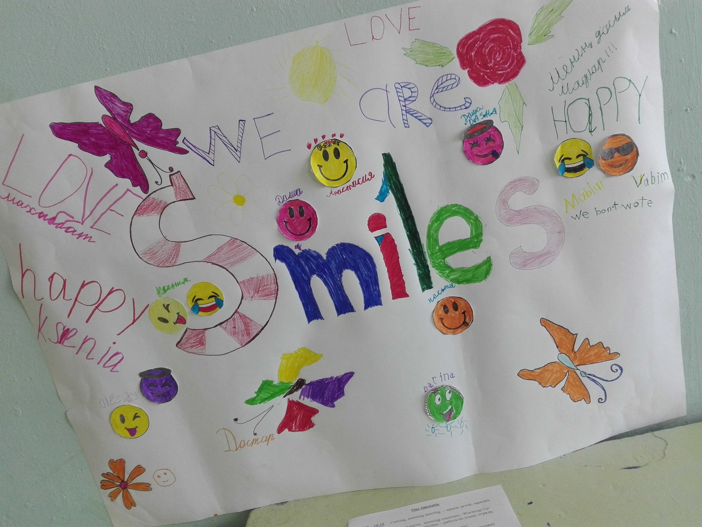
- We do “Circle of joy” Every morning
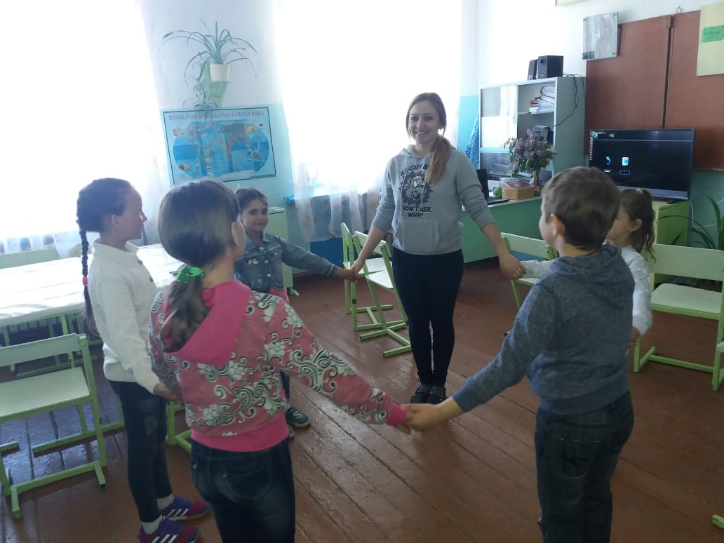
3.Learning song “ If you are happy..”
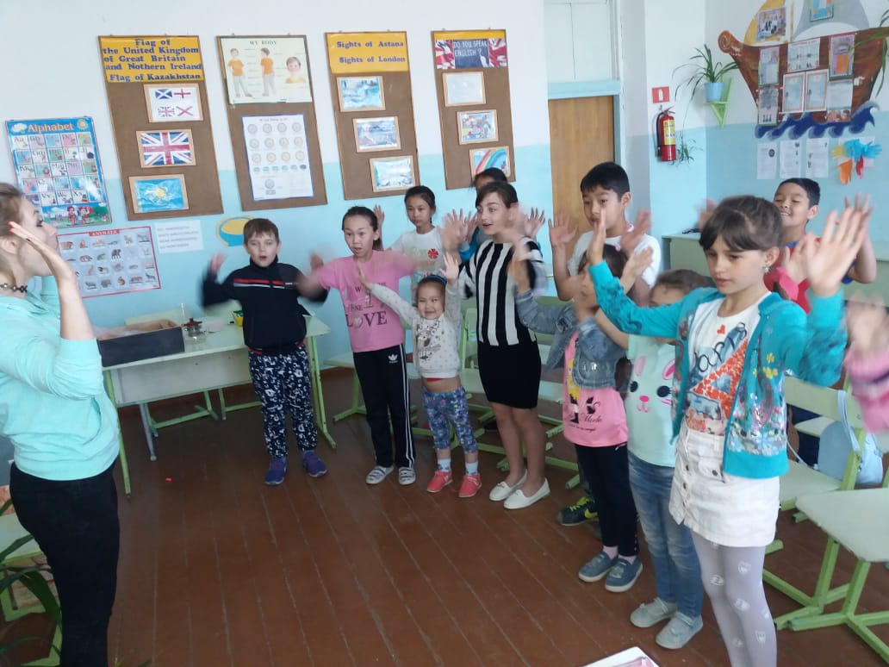

Day 3 (07.06)
Theme: My family. Менің отбасым.
Learning of the family’s names.

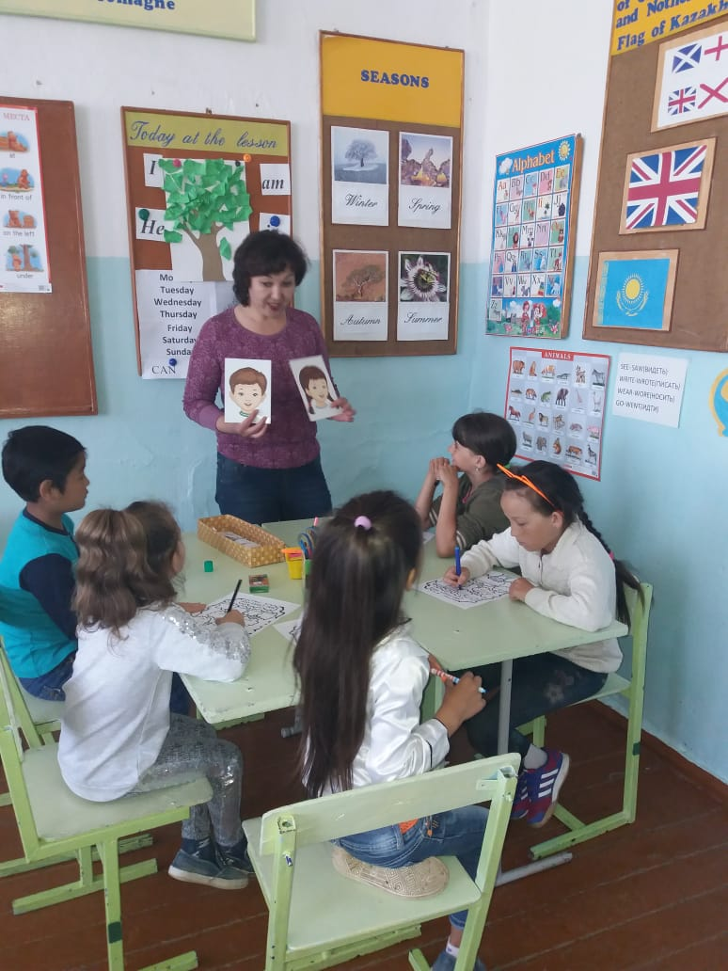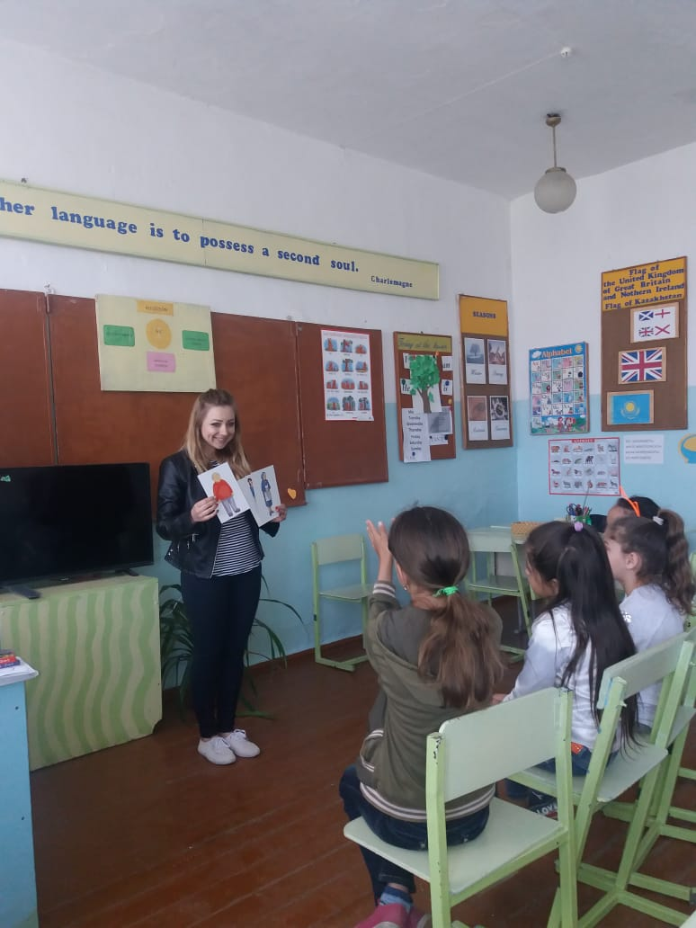
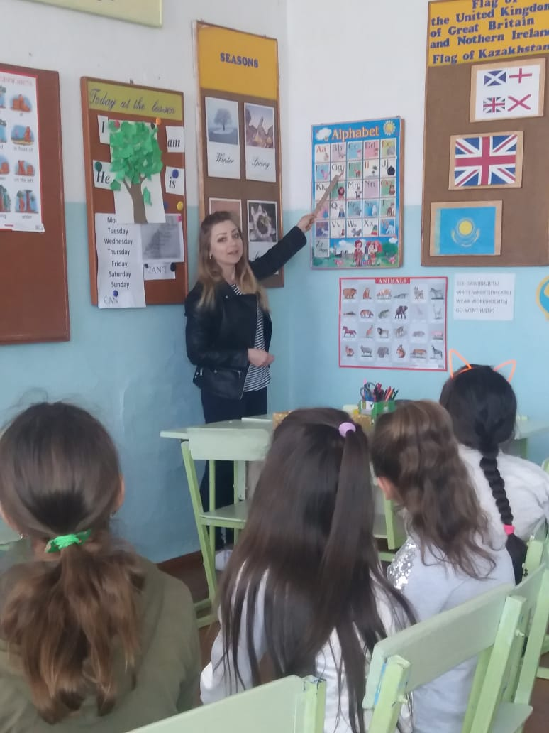

Day 4 (08.08)
Theme: My pets. Менің сүйкімді жануарым.
Learning names of the animals
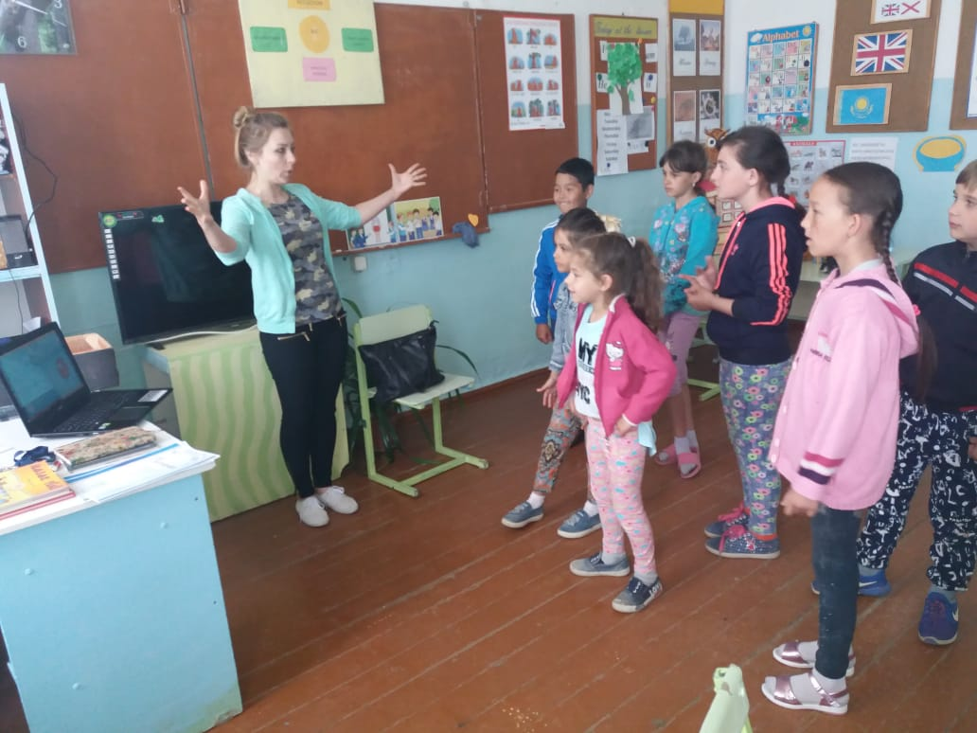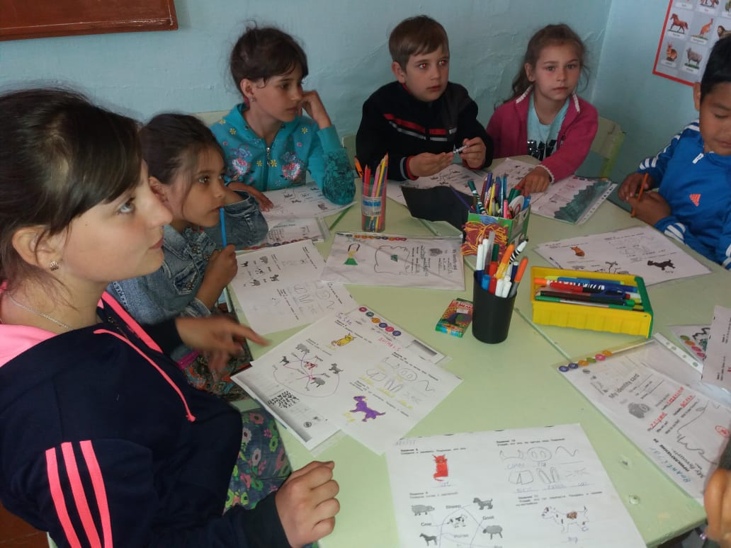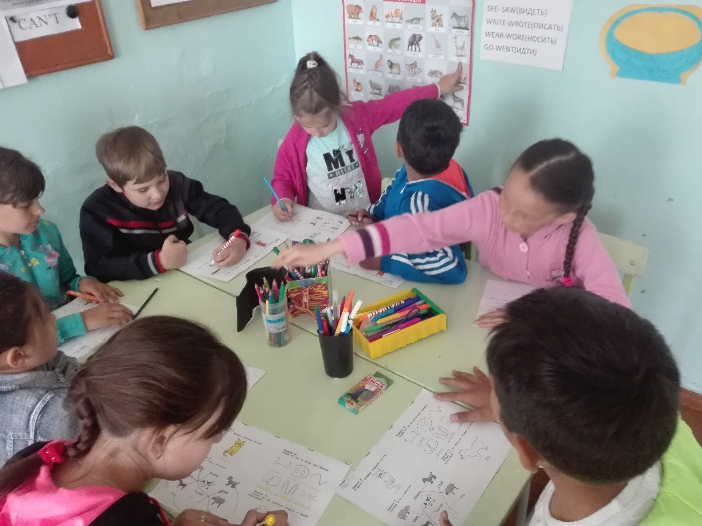

Day 5 (11.06)
Theme: My hobby. Менің ермегім.
Learning names of the hobby.
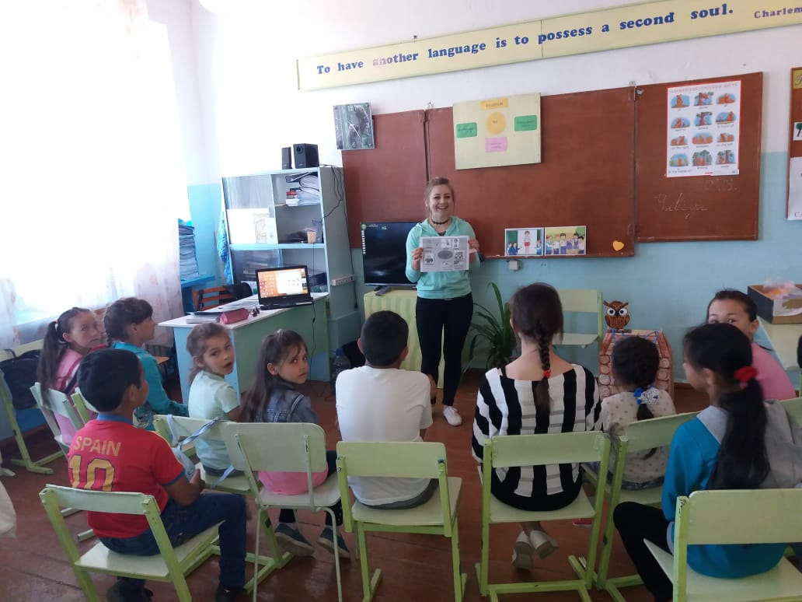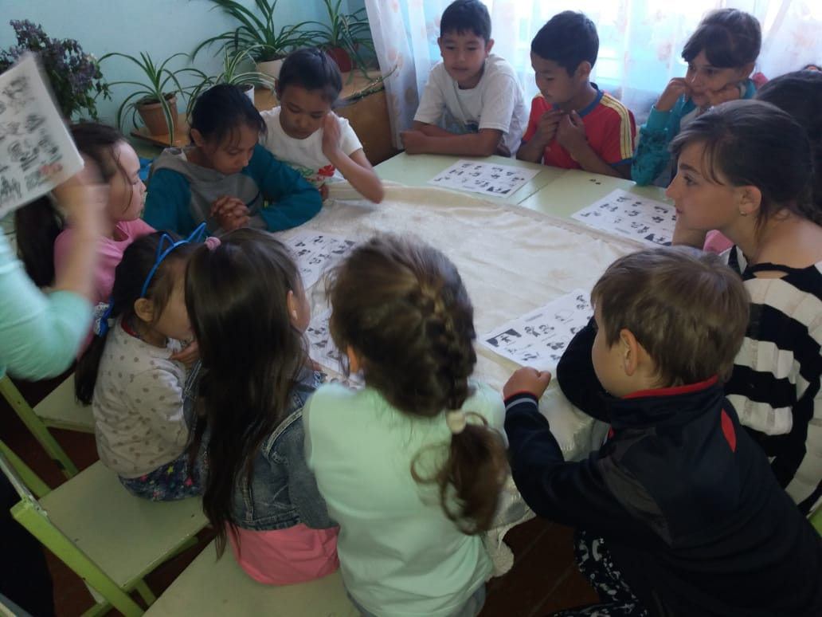

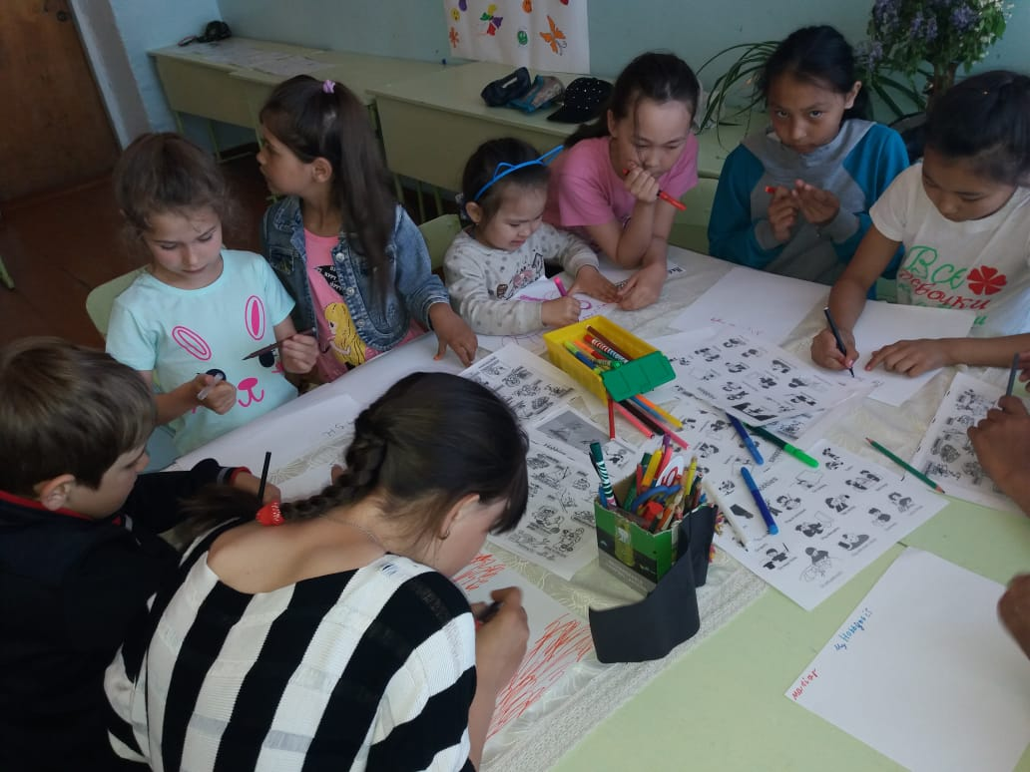
Day 6 (12.06)
Theme: My school garden. Менің мектеп аулам.
We have a picnic
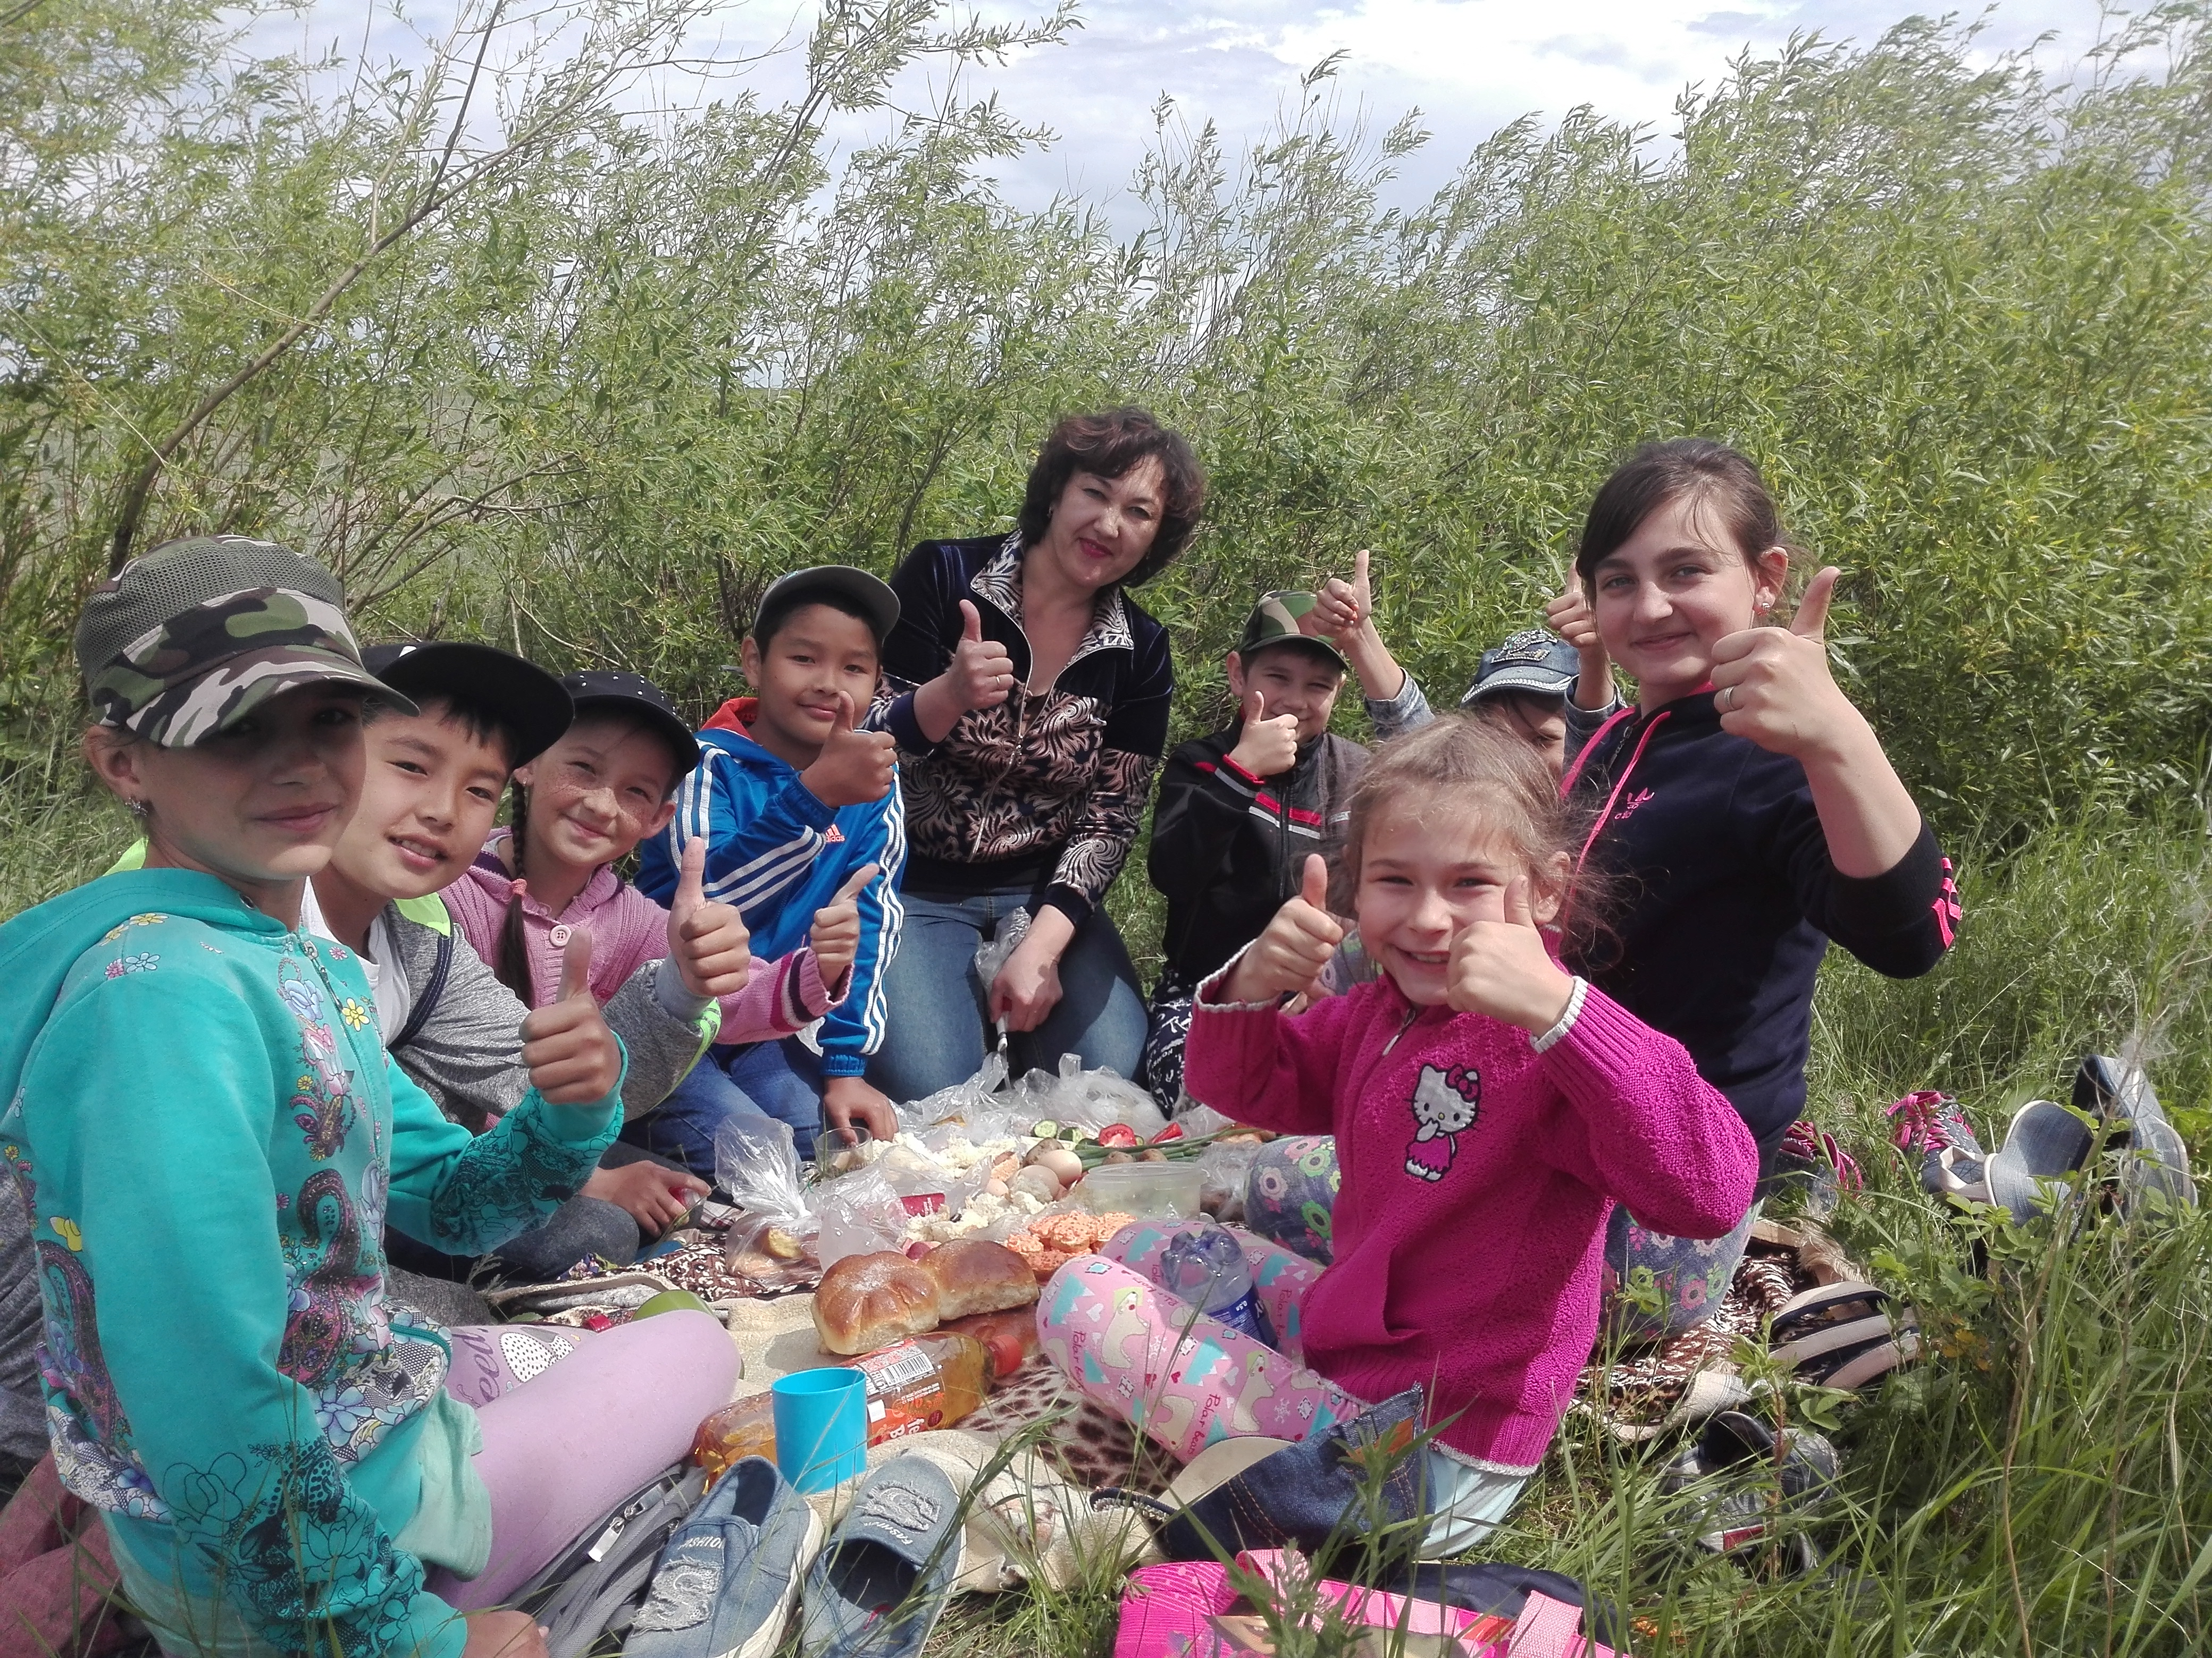

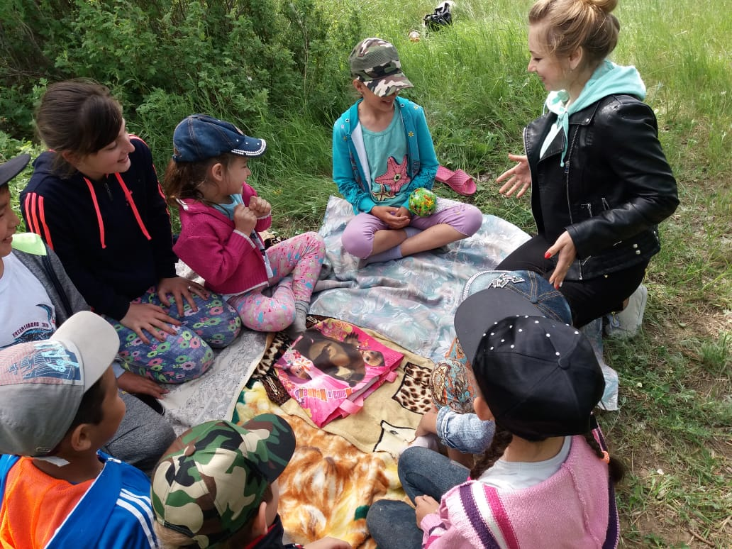Playing the Game “ You hold….”

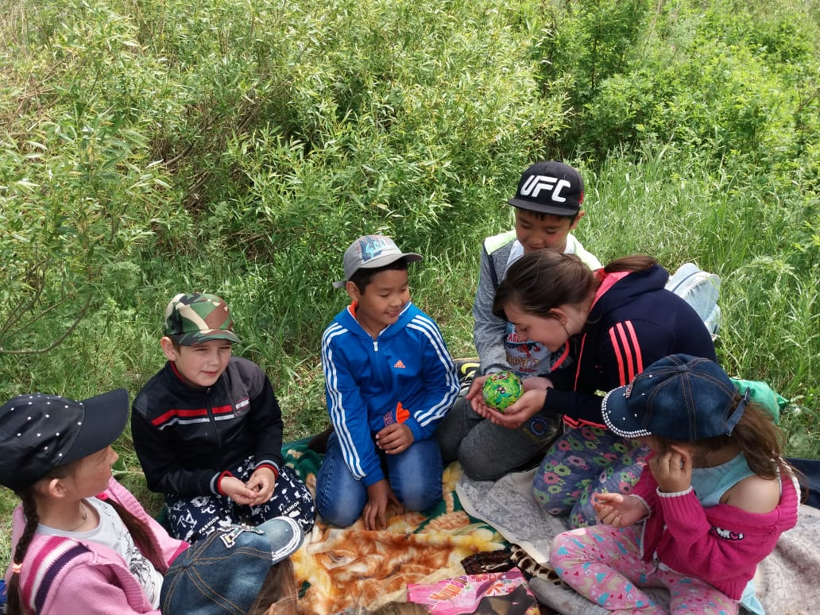

Day 7 (13.06)
Theme: English and Kazakh food. Ағылшын-Қазақ тағамдары.
Learning English and Kazakh food : Apple Pie and Shelpek and eating it.
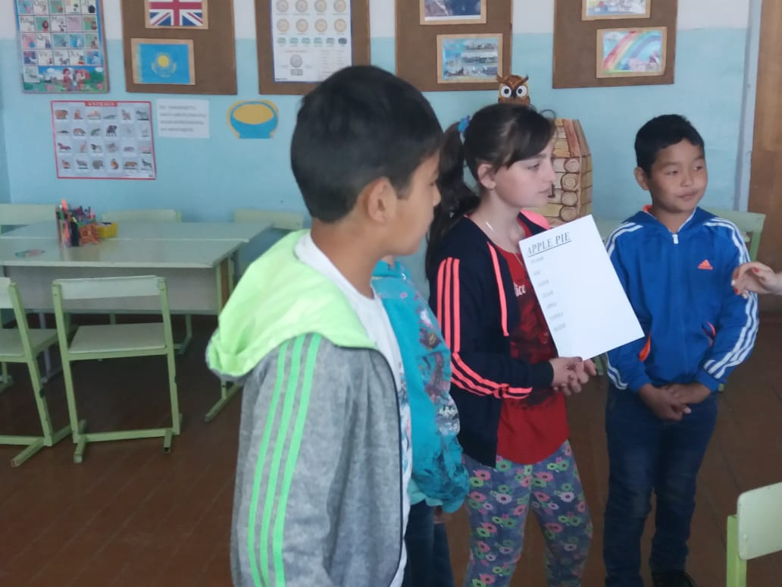

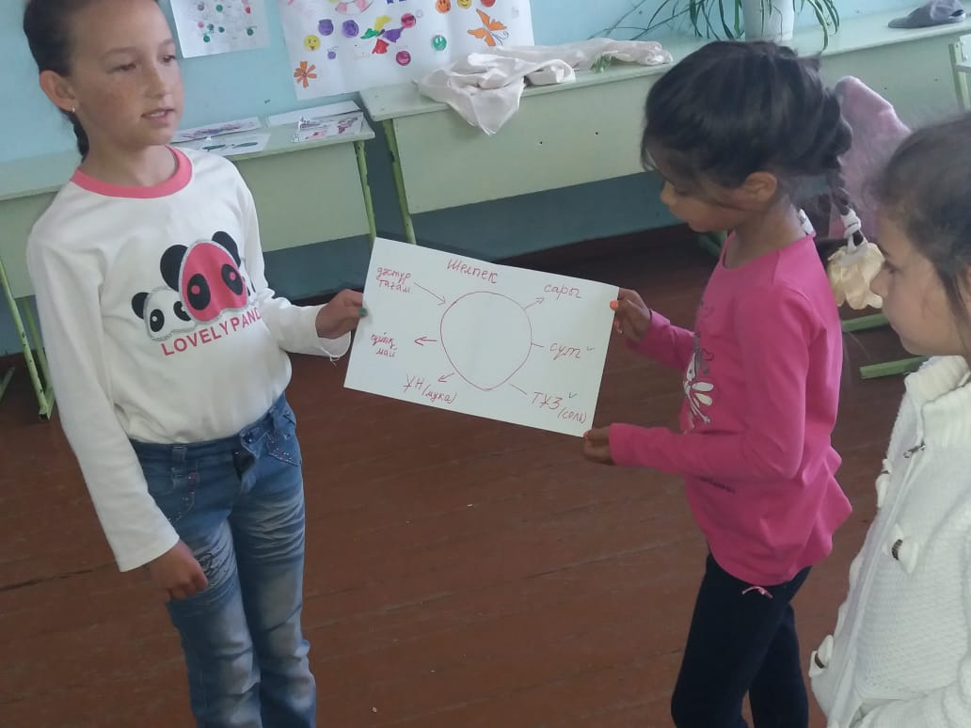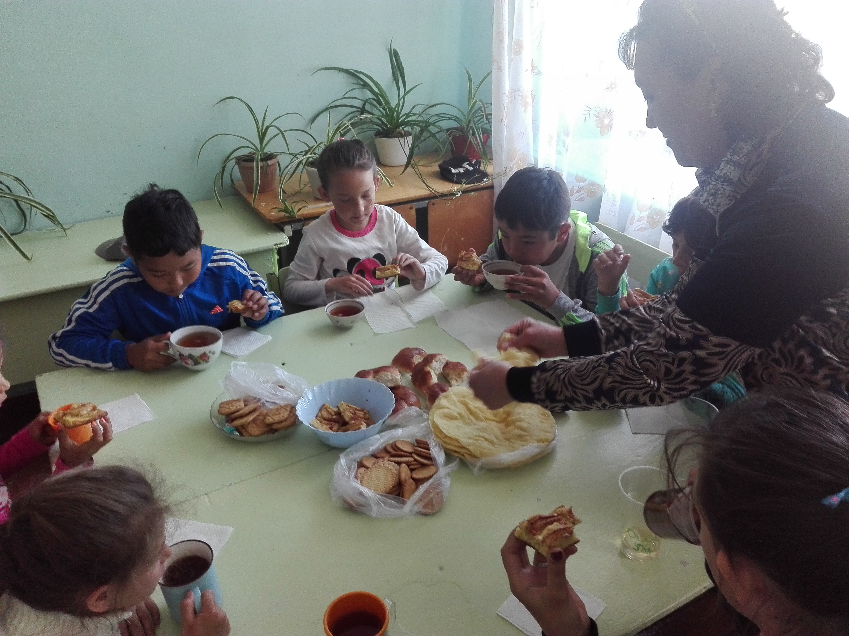Dramatization of an English fairy tale “A Little House”
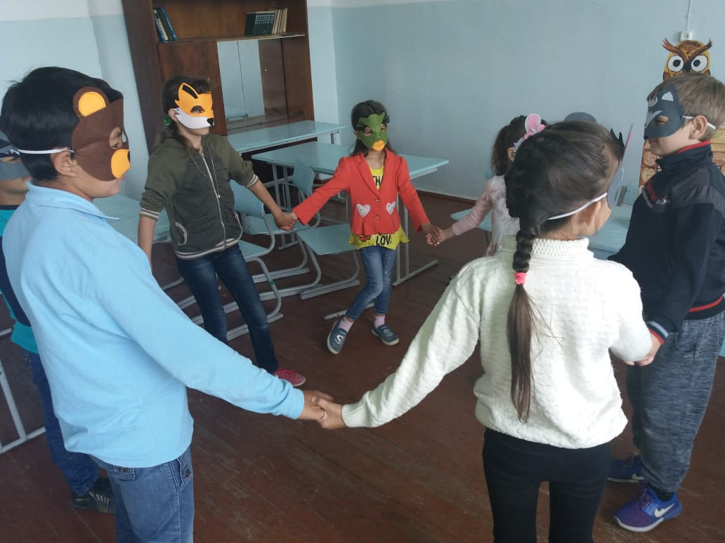
Day 8 ( 14.06)
Theme: The Weather. Ауа-райы.
1.Studiing of the types of Weather
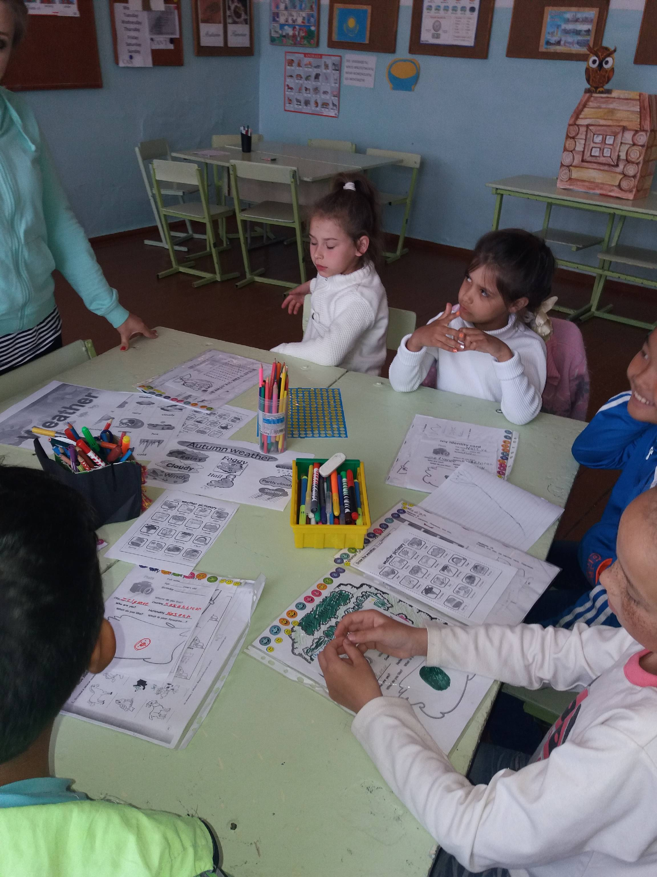

2.Dramatization of an English fairy tale “A Little House”
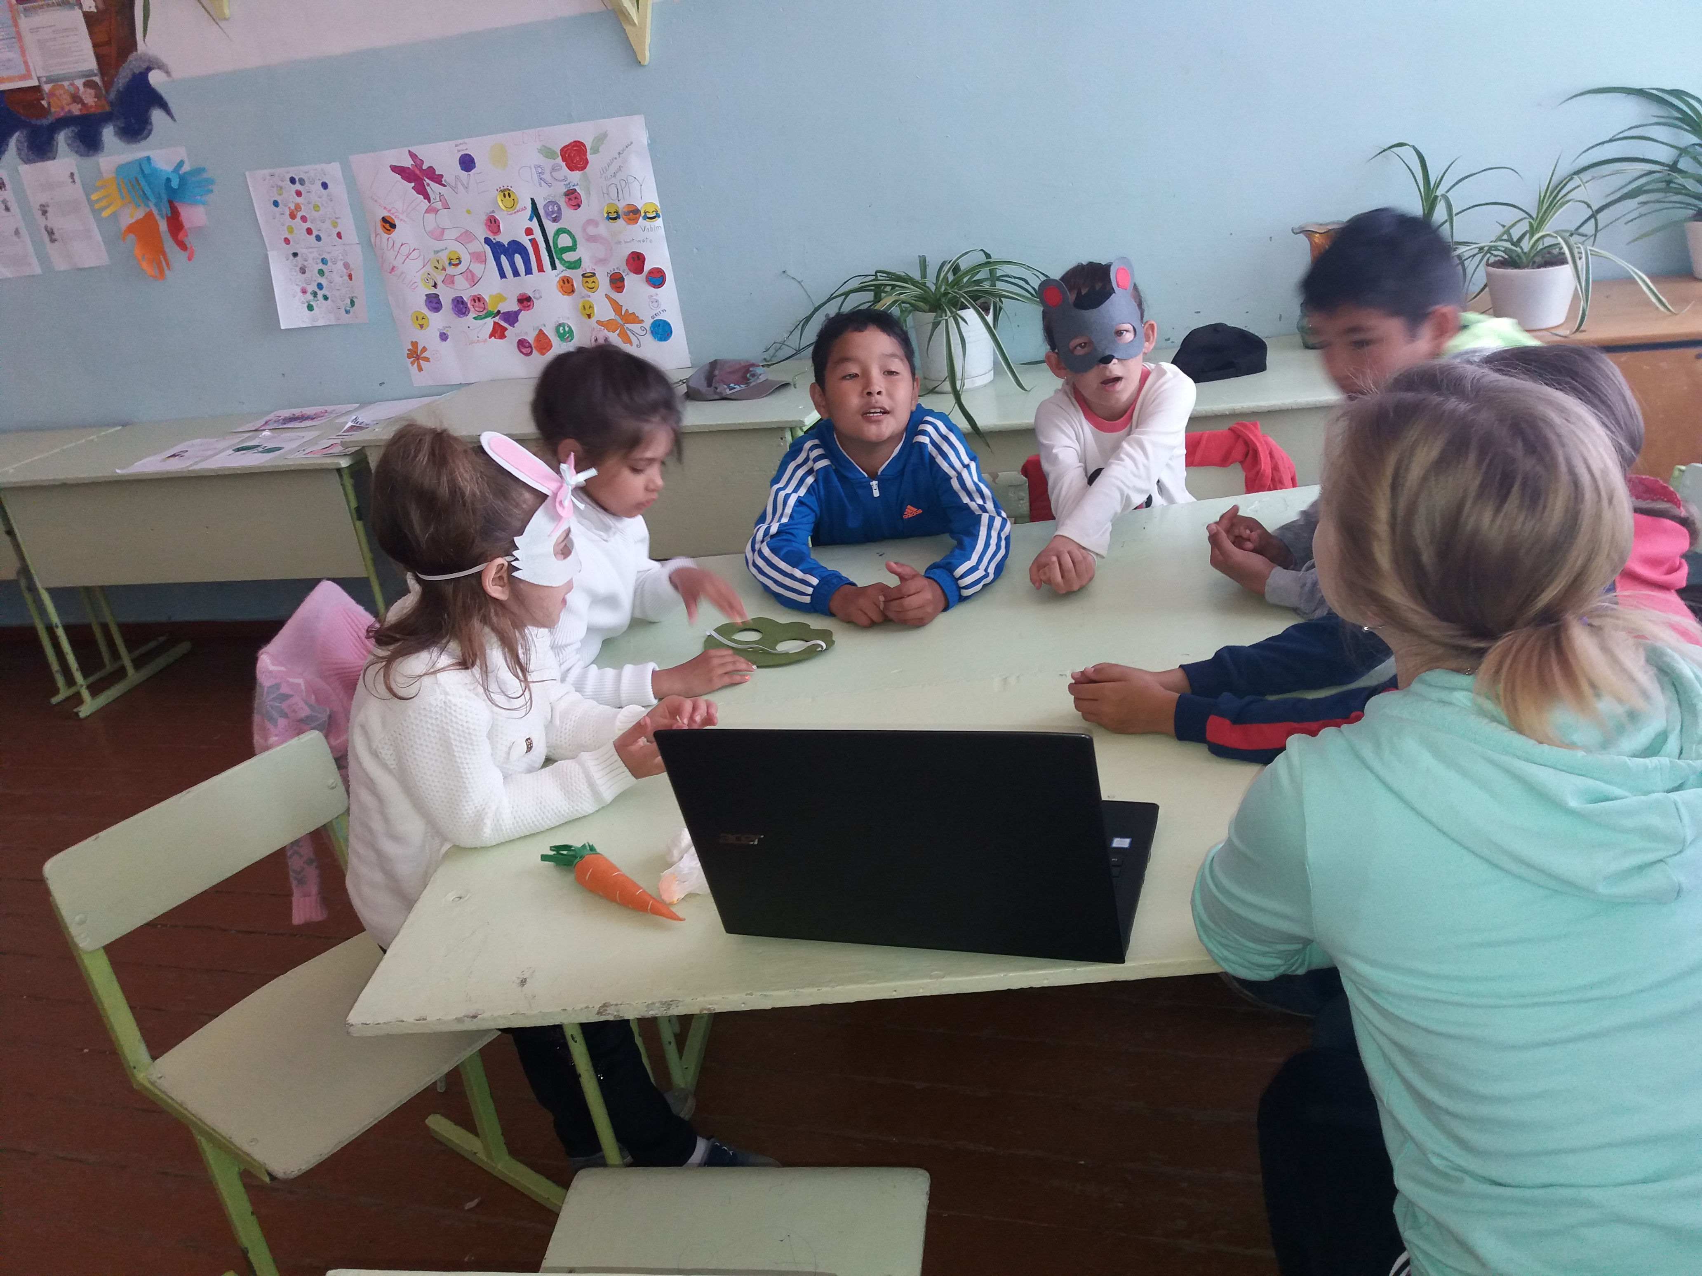

Day 9 (15.06)
Theme: English and Kazakh national games . Ағылшын –Қазақ дәстүр ойындары.
Morning work-out
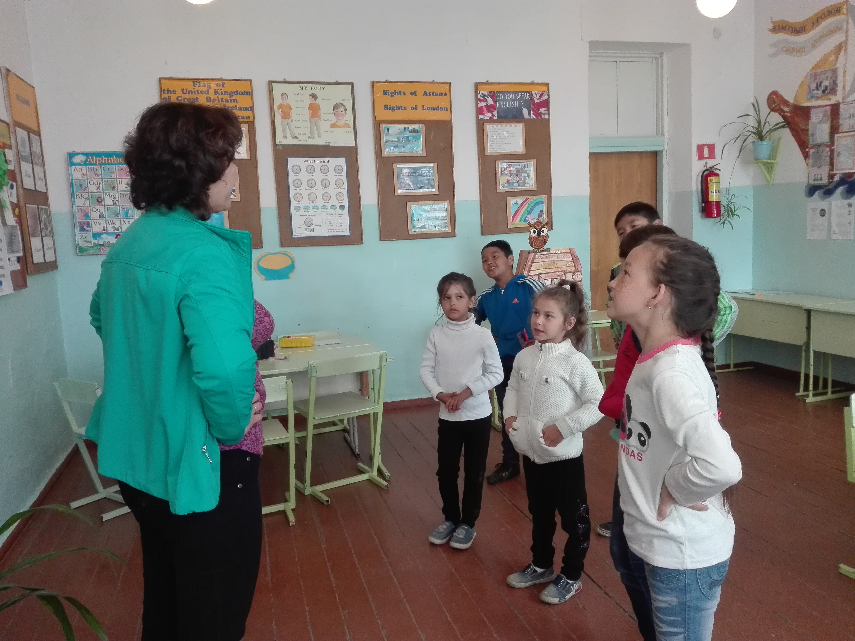

Acquaintance with the National English Game “ Fox and Geese”
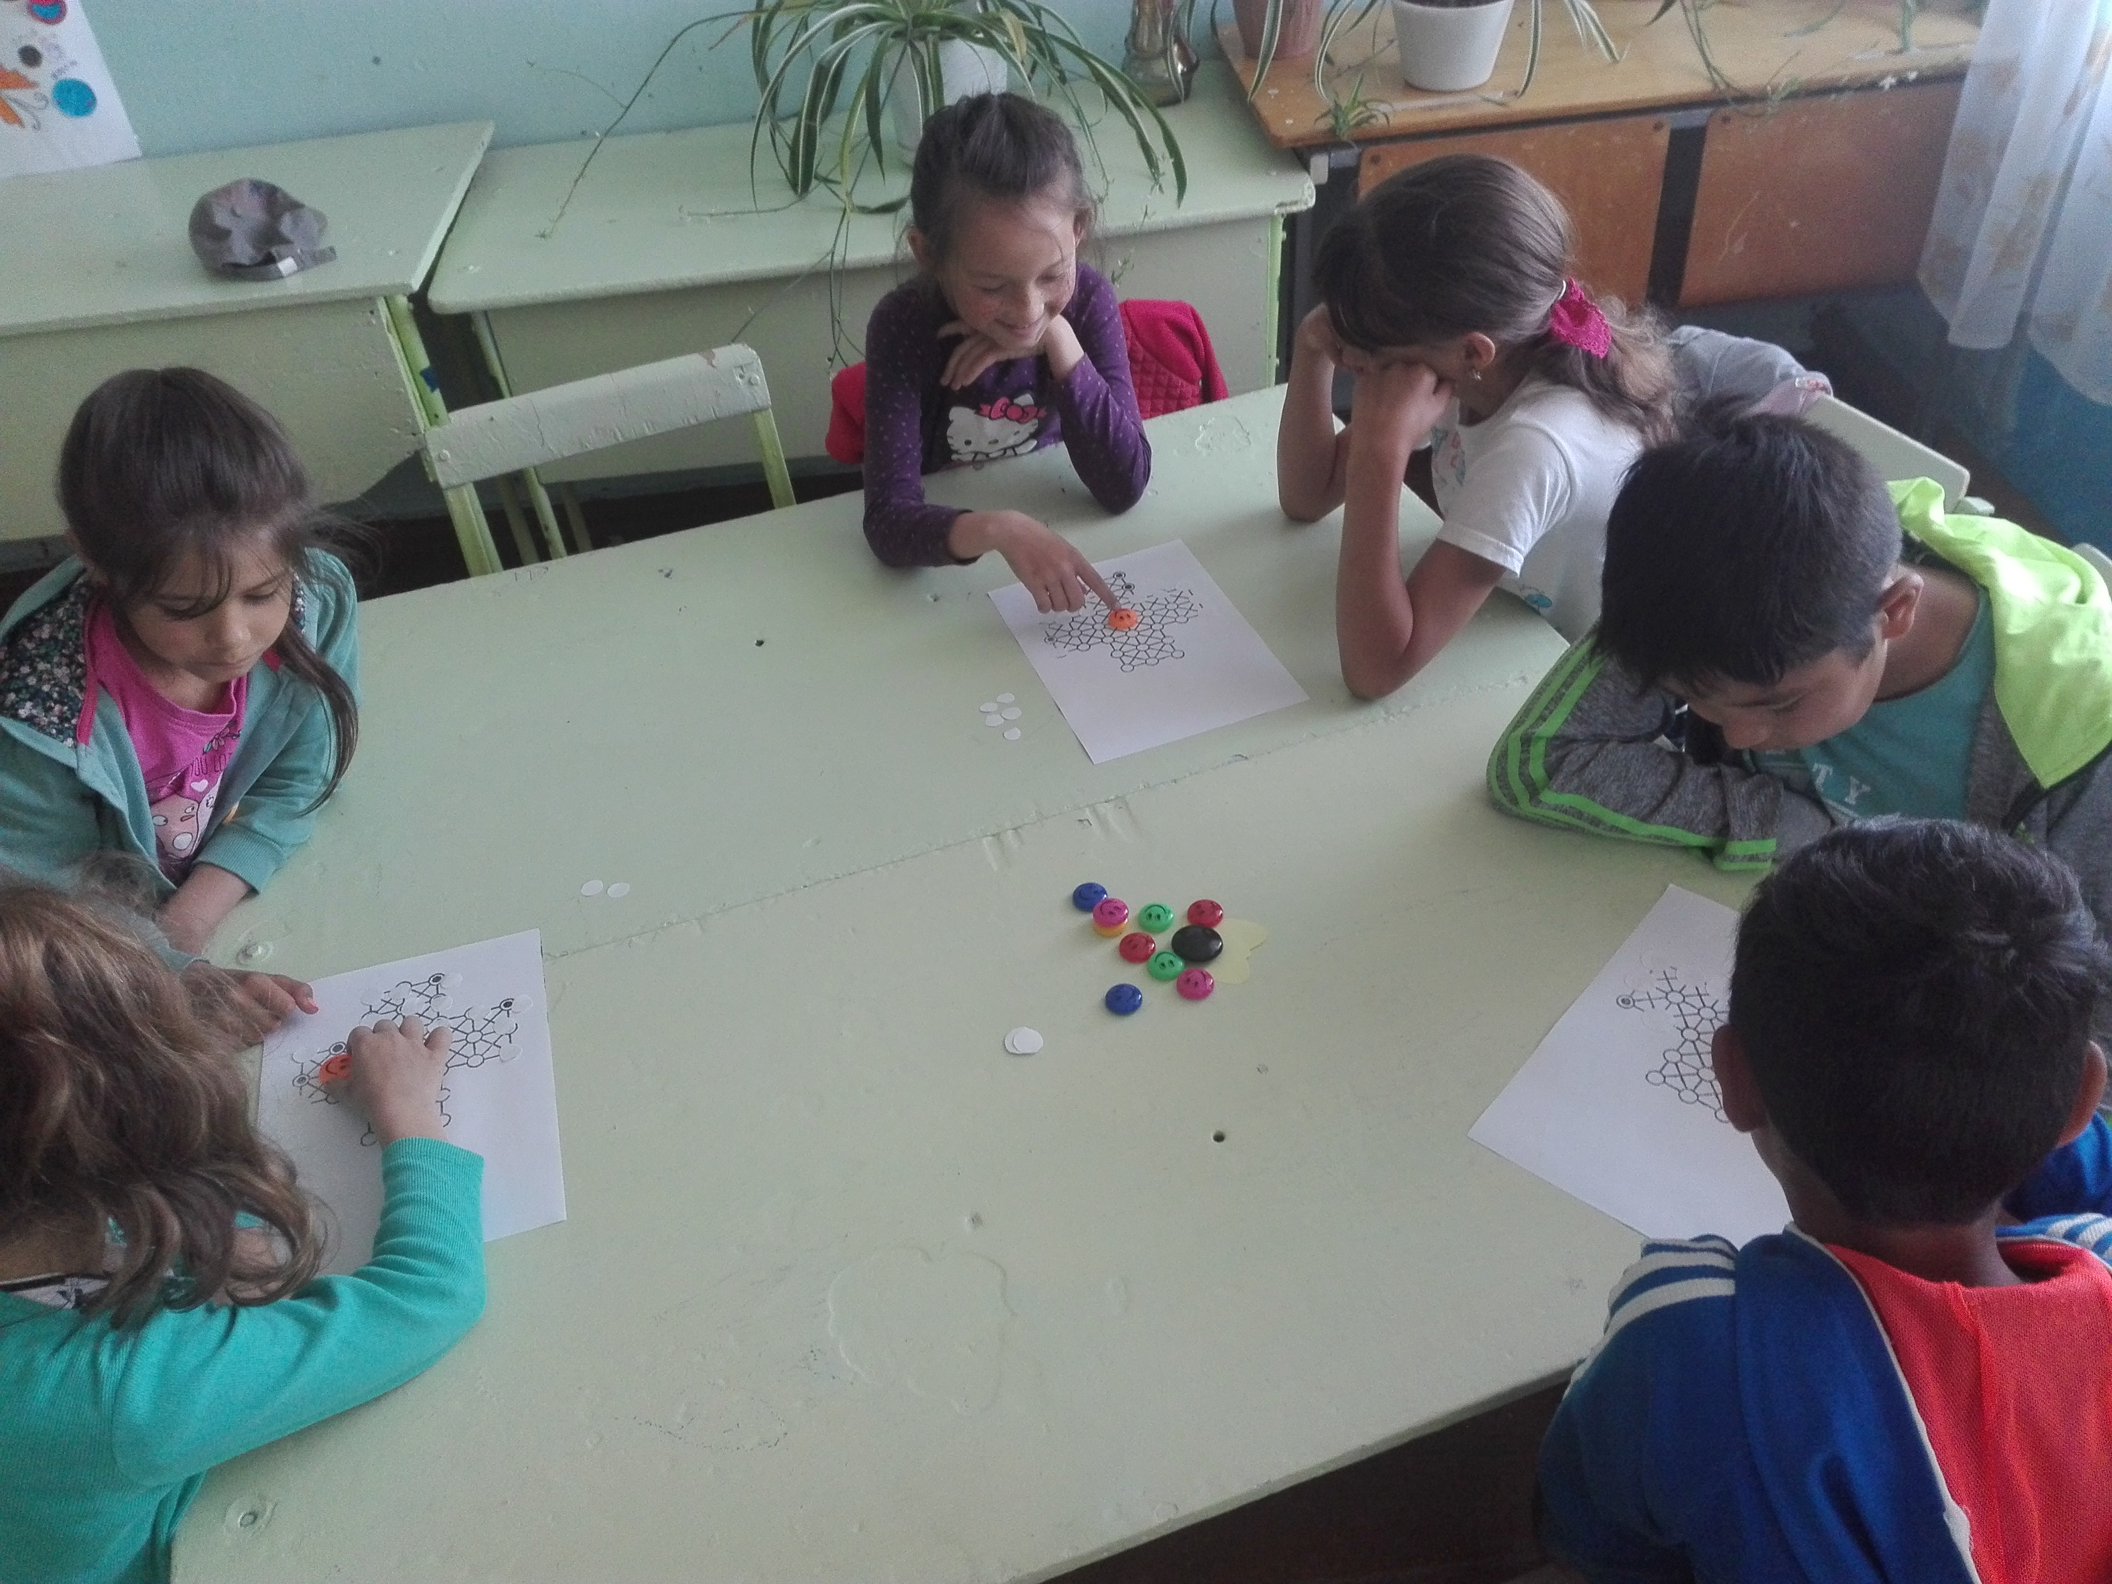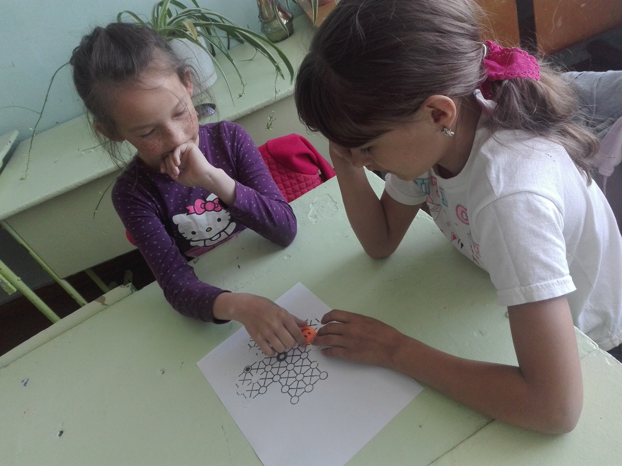

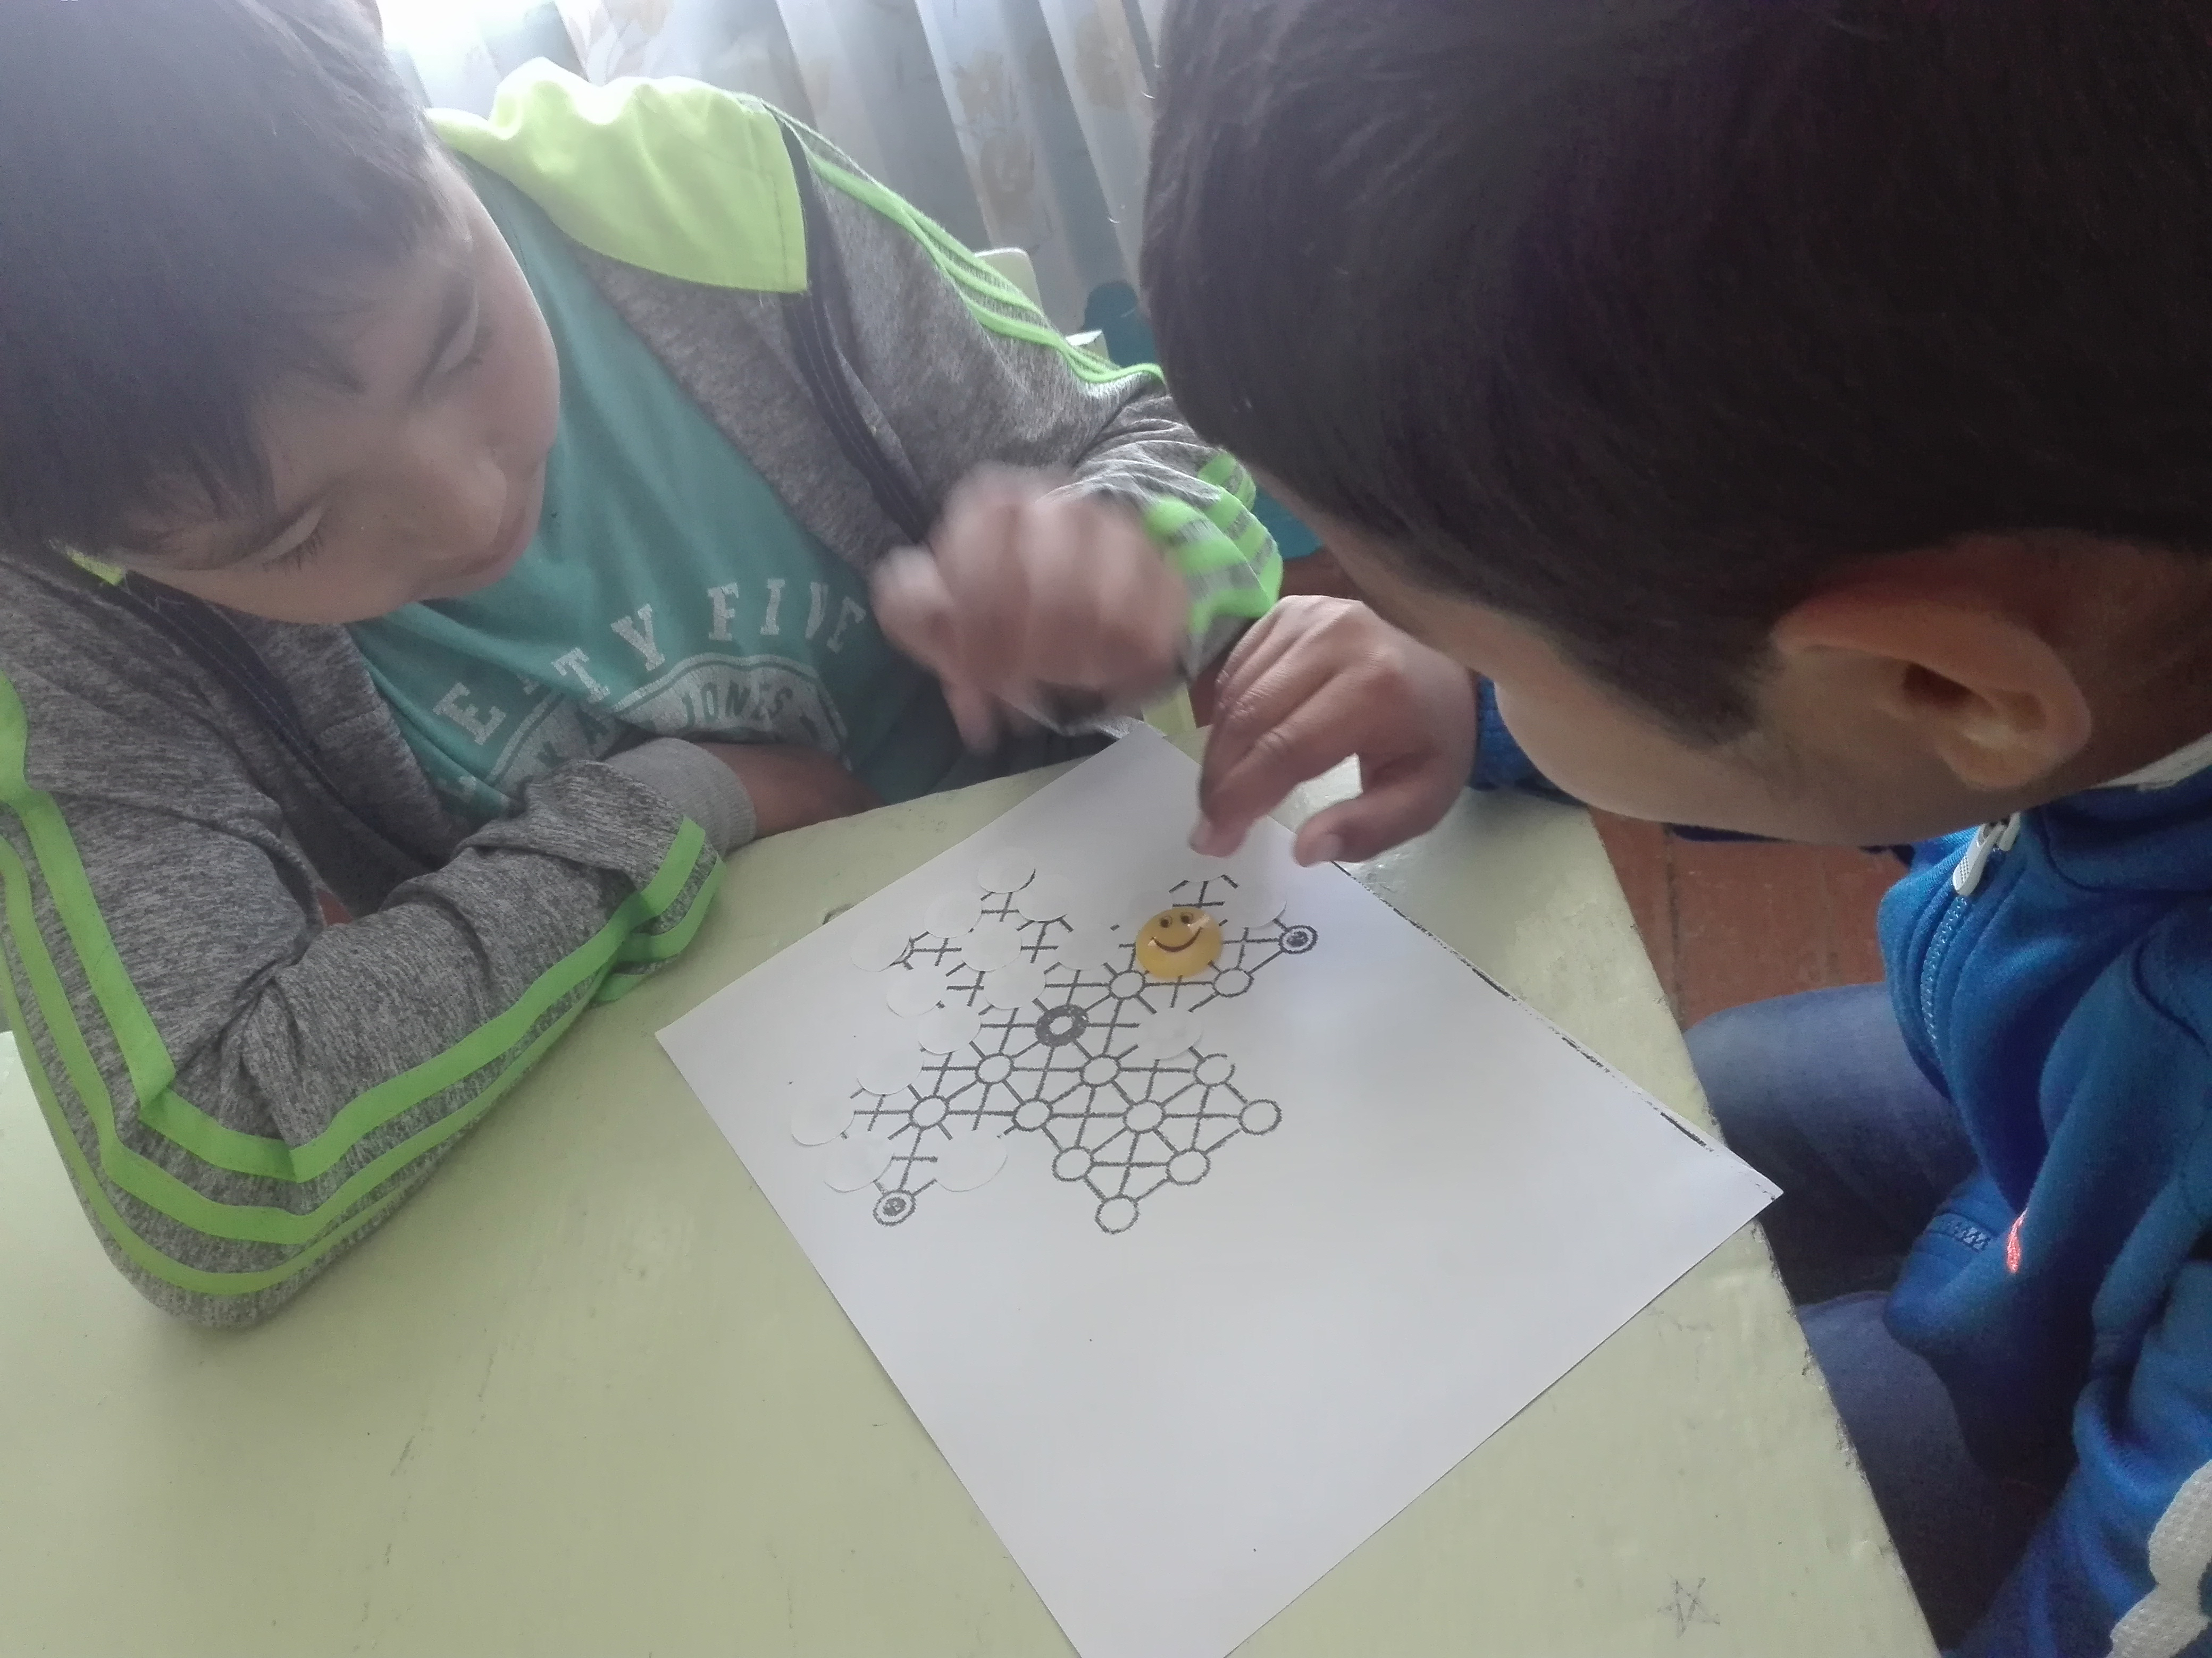
Day 10 (18.06)
Theme: English and Kazakh films.Көркем фильм көрінісі.
English and Kazakh songs.

Day 11 (19.06)
English and Kazakh fairy tails
Day 12 (20.06)
Theme: Fashion and style
Day 13 ( 21.06)
Theme : Sport

Day 14 (22.06)
Theme: Closing of the Summer Language Centre

